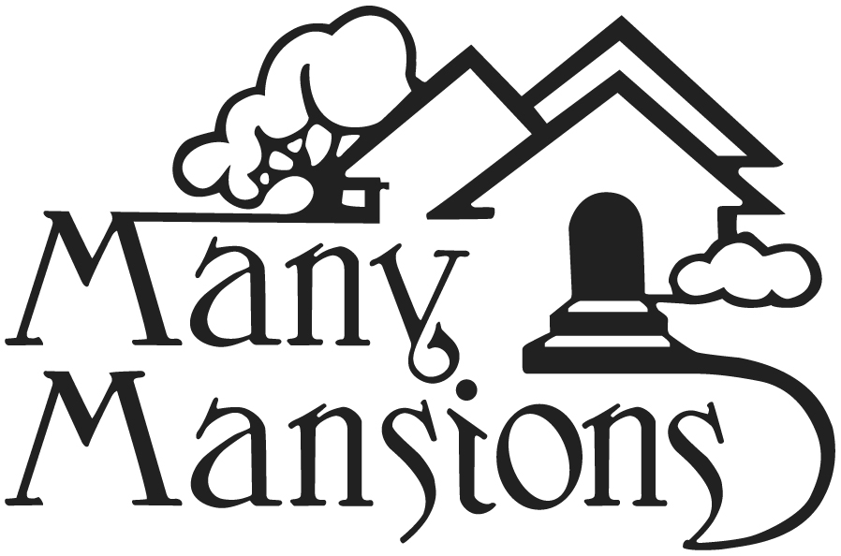

Job Description

Community Manager (Full Time)

Overview:

Category | Information
Job Title | Community Manager
Division | Property Management
Status | Non-Exempt:
Hours | Full-time
Supervisor/ Reporting | Regional Manager
Supervisorial Responsibilities | Maintenance Technician

Description (brief)

The Community Manager is responsible for the overall operation of the property and the day-to-day implementation of policies, procedures and programs that ensure a well-managed, well-maintained building and ensures compliance with all applicable regulatory agencies and federal, state, and local laws.

Essential Job Duties & Responsibilities:
To perform the job successfully, an individual must be able to perform each essential duty satisfactorily. The duties of the position of Community Manager include, but are not limited to, the following:

No. | Essential Duty or Responsibility
1 | Communicates effectively with internal and external customers, working after hours when necessary;
2 | Ensures compliance with Affirmative Fair Housing regulations and Equal Opportunity/Affirmative Action policies, including federal, state, and local governing agency requirements;
3 | Maintains accurate written records, in accordance with all governing agency requirements, taking corrective and/or legal action as needed;
4 | Works with maintenance team to implement maintenance programs and controls, including negotiations with outside vendors;
5 | Ensures the property's move in, move out, and renewal processes are timely and accurate, ensuring the property’s re-certifications are completed timely and accurately;
6 | Makes regular inspections of apartment community;
7 | Provides required financial reporting along with recommendations to address financial issues;
8 | Reviews incoming rent schedules, scheduled rent increases, and renewals, while ensuring rents allowed match the governing regulatory program for the property;
9 | Prepares and adheres to the properties budget and;
10 | Other duties as assigned.

Qualifications & Conditions:

Category | Qualification or Condition
Communication | Possesses good communications skills, including but not limited to, the ability—  - To speak and write clearly, meaningfully, and persuasively;  - To speak, listen, and respond effectively with and among staff, agencies, residents, donors, lenders, investors, partners, and community members;  - To speak and write Spanish clearly, meaningfully, and persuasively is desired.
Computer Skills | Has proficiency in computer and computer applications, including Microsoft Office programs (Word, Excel, PowerPoint, and Outlook), social media, and data management programs. Should have some familiarity with Yardi, iCam or other Property Management software.
Driving | Driving is required for this position.  Therefore, the staff member must have the legal ability to drive a motor vehicle in California, proof of a valid California driver’s license, and adequate motor vehicle insurance.
Education, Experience, & Certifications | Has at least 2 years of property management experience.  - Experience with managing low-income affordable housing properties is desired  - Experience with affordable housing programs like Section 8, Section 42, MHP, AHP, etc. desired  - A nationally accredited certification like ARM, CPM, CAM, CAPS and SCHAM desired  - High school diploma or GED required  - BA degree is preferred
Leadership & Other Skills | Has a demonstrated ability to work well with others and provide leadership. Must be self-motivated, creative, and have ability to set priorities independently. Must be able to adhere to all company policies and procedures, in addition to all State, federal and local laws and regulations.
Mathematical & Reasoning Skills | Possesses excellent mathematical and reasoning skills. This includes, but is not limited to, the ability to perform basic mathematical skills (add, subtract, multiply, divide, fractions, decimals, etc.), the ability to resolve practical problems and deal with a variety of concrete variables in situations where only limited information exists, and the ability to interpret data and/or instructions.
Physical Demands | While performing the duties of this job, the staff member is regularly required to sit, use hands to finger, handle, or feel objects, tools and/or controls, talk and hear. The staff member is occasionally required to stand, walk, and reach using feet, legs, back, arms and hands. The staff member must be able to lift and/or move up to 20-40 pounds. Specific vision abilities required by this job include close vision, distance vision, color vision, depth perception and the ability to adjust focus.
Work Environment | This job position has a moderate to high stress work environment.  The work environment may have frequent interruptions, time constraints, and emotional demands. Noise level is low to moderate. The corporate culture is friendly and goal oriented.  The work environment characteristics described here are representative of those a staff member encounters while performing the essential functions of this job.  There must be willingness and an ability to work nights and weekends, as needed.

Reasonable accommodations may be made to enable individuals with disabilities to perform the essential duties and functions.

Reasonable accommodations may be made to enable individuals with disabilities to perform the essential duties and functions.

Certifications

A copy of this Job Description was given to the staff member.

Date: ________________ ____________________________
(Supervisor or Human Resources)

I received a copy of this Job Description.

Date: ________________ ____________________________
(Staff Member)

